

**Informatics College Pokhara**



**Artificial Intelligence -CU6051NI**

# Individual Coursework-1

**Submitted** **To**:

Mr. Abhinav Dahal

Module leader

Artificial Intelligence

**Submitted** **By**:

Name: Milan Tilija

London Met ID: 20048683

Group: C2

Date: 10/12/2022

# Introduction

With good reason, AI is presently one of the most popular terms in technology. Over the past several years, several advancements and innovations previously only seen in science fiction have progressively become realities. Artificial intelligence (AI) and digitalization are changing how we work, live, communicate, learn, and play. We, humans, are increasingly using enhanced technologies like AI in our daily lives which may also have a substantial impact on our lives. AI is revolutionizing all aspects of human existence. The first AI thought to be a checker-playing computer was developed in 1951 by Christopher Strachey, Oxford University UK. (Copeland, 2022).

Artificial intelligence (AI) is the simulation of human intelligence in machines that are programmed to perform tasks commonly associated with intelligent beings and mimic their actions. (FRANKENFIELD, 2022). For instance, Siri is one of the most famous inventions in the technology world. Siri is a voice recognition that can understand natural human language and performs a task like answering a question, reading messages, searching on the internet, and many more which reduce time and complexity. Machine learning is one of the subsets of artificial intelligence which can automatically learn from and adapt to new data without being assisted by humans. The ideal characteristic of AI is to the ability to justify and take actions to achieve the specific targeted goals.



**Figure 1 Artificial Intelligence**

Nowadays AI has been used in different industries from finance to healthcare. AI inventions are just begun and those technologies are being tested in various fields. Some of the most renowned applications of AI are in the healthcare industry for dosing drugs and doling out different treatments tailored to specific patients. Auto-playing chess and autopilot like Tesla have become one of famous technologies invented. Artificial intelligence has applications in the finance industry, which helps banking and finance to regulate the economic flow of money. (FRANKENFIELD, 2022)

Artificial intelligence is categorized into two parts which is weak AI and strong AI. Weak AI is also known as narrow artificial intelligence which describe that it is limited to a specific or narrow area. It can simulate human cognition like learning, perception, reasoning, problem solving and other activities that a human can perform. By making predictions and detecting patterns weak AI helps in converting big data into usable information. Facebook newsfeed, Amazon’s suggested purchase and Apple’s Siri, that response user’s commands are some of the example of weak AI. (Frankenfield, 2022). Strong and super AI is only the theoretical AI at this point. When a machine will have full cognitive abilities, doesn’t required human for instructing machine, and machines act, feel, respond and think like humans. (Marr, 2021).

AI can significantly reduce errors and increase, accuracy and precision based on information gathered and a certain set of algorithms. AI is available anytime as it doesn’t feel tired, weak, or stressed. The productivity of products and profit of the company can be boosted by AI certain inventions like recommendation systems, and chatbots for a frequent response. More and more national arrangements are centering on AI, which is being consolidated into and affecting mechanical and agricultural forms, administrations, esteem chains, and the organization of work environments. AI has the potential to improve people’s lives, but it too raises several important approaches, moral and social issues, counting job creation and work out-of-date quality. It speaks to a source of social and political pressure, and dangers exacerbating inequalities inside and over nations. (Duggal, 2022).

This project is all about conducting research on one particular AI issue among several AI topics. Recommendation systems, a highly popular and frequently used AI concept, are studied in this study. For developing recommendation systems, there are several approaches and algorithms. Collaborative filtering, one of the most widely used algorithms. In this algorithm, similarities between users and specific items are used to recommend products and items to another person. Today, recommendation systems are utilized extensively on streaming websites like Netflix and YouTube as well as commerce sites like Amazon, Daraz, others.

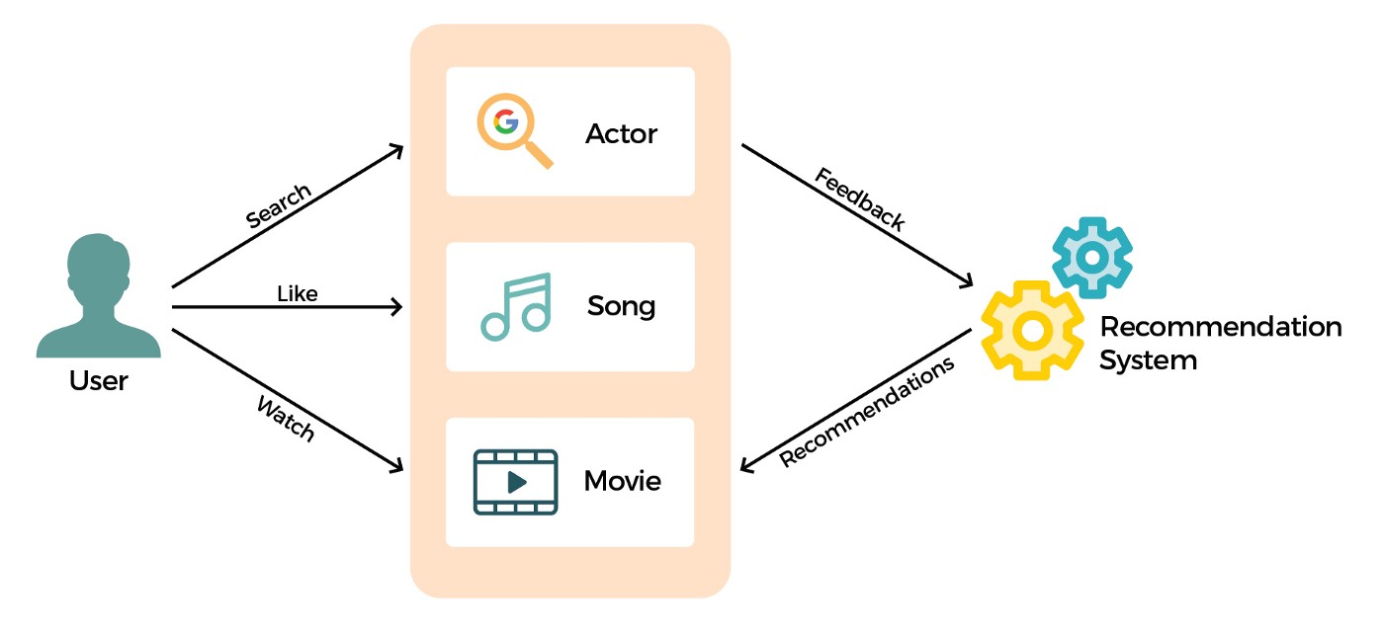

**Figure 2: Recommendation system.**

## Explanation of the topic

A collaborative filtering algorithm-based movie recommendation system is the topic I've chosen for my project. Users will be given recommendations for movies that are related to their interests and preferences. Recommender system has the ability to predict whether a particular user would prefer an item or not based on the user’s profile. Datasets are required to train the system which is taken from Kaggle. Kaggle is a cloud-based platform for data scientists and machine learning enthusiasts. It provides resources and powerful tools for learners and professionals. Kaggle offers GPU-integrated notebooks, assists in finding and publishing datasets, and enables user collaboration. (Moltzau, 2019). Many of the well-known streaming services, like Netflix, YouTube, Prime Videos, and many more, use movie recommendation systems to provide the best user experience.  recommendation systems to provide the best user experience.

The majority of individuals like to watch movies when they have free time. The movie recommendation system that this coursework will construct is like a system that predicts users’ movie preferences based on their past choice and behaviors and suggests movies that a corresponding user had watched It shows those movies/films which different viewers are watching and assumes that other viewers would watch similar movies. How does movie recommendation work? The system keeps records of the past preferences of the users and utilized that information and tries to find out similar movies and recommend those movies to users. The movie is not recommended based on rating only, there might be other factors like lead actors, directors, genre, theme, language, and many other factors. (Kniazieva, 2022)

Collaborating filtering algorithm is a subclass of an information filtering system. The information filtering system is a system that removes redundant or unwanted information from an information stream using semi-automated or computerized methods before displaying human users. Collaborative filtering filters information with the help of other users’ interactions and data collected from them. (Whitefield, 2022). It mainly focuses on the relationship between uses and items. Like when a user gave a positive review for an item they liked, the system may utilize that information to identify the user. After the information gathering of users, the system will show similar types of the products. Big organizations like GroupLens use recommendation system in order to assist users to locate articles, Amazon uses topic divarication algorisms to improve its recommendation. (Journal, 2015)

Collaborative filtering system is divided into two types which are user-based and item-based filtering system**. User-based collaborative filtering** is based on similar users and their choice and their rating of the item they already used. For example, user A gives 3 ratings to product A, 4 ratings to product B, and 5 ratings to product C out of 5 ratings. Likewise, if user B gives a 3 rating to A and 4 rating to product B then product C will be recommended to user B because the taste and rating of user A and user B are similar. (geeksforgeeks, 2020). In **item-based collaborative filtering**, products are recommended based on taste, similarities, and ratings the users had given to the similar product. In this type of technique, similarities between items are computed and similar items are displayed to users based on the similarities computed. (Saumyab271, 2021).

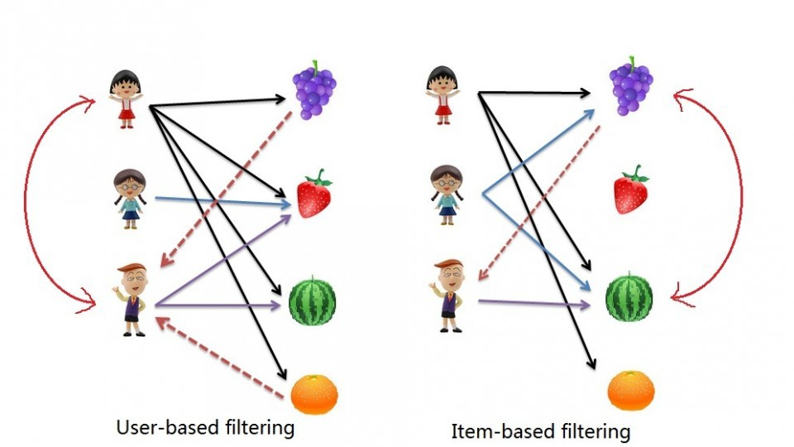

**Figure 3: Types of collaborative filtering recommendation system.**

## Explanation of the chosen problem domain

Most of the time, decisions must be made without the benefit having past information or experience. We rely on reviews of general surveys or recommendations made by other people in our everyday lives. Rapid increases in both the volume of digital information available and the number of Internet users have raised the possibility of information overload, which makes it more difficult to access online resources quickly. Likewise, generalizing a movie and assuming that everyone will like it is quite tough. (Sarika Jain, 2015) Everyone enjoys viewing movies at home, regardless of gender, age, or geographic location. Many individuals prefer romance, action, or comedy films, while others love the visions of the leading performers and filmmakers. A recommendation system has become a highly in demand technology because it can predict the needs and preferences of the user. Netflix organized the competition with the grand prize pool of US$1000000 on September 21, 2009 for developing the best recommendation system based on user rating to movies. This competition put a spotlight on the importance and requirement of recommender system in real world applications. (Basilico, 2015).

With the rapid growth of the Internet, online movie streaming technologies has gained a lot of traction in the massive extraction of data and providing better experience for the user. The movie streaming platforms and networks are expanding, the user won't be satisfied if they can't find the movies they want to watch. The consumer disliked wasting a lot of time searching for a suitable show or movie to watch. Therefore, if the system can propose a movie to them based on user behavior, taste and preferences then the user can find suitable movies for them and will engage in the system. Consequently, movie recommendation systems are incredibly helpful for users as well as service providers like Netflix and Prime Video The time required to discover a move and the problems with selection will be totally eliminated. It encourages consumers to use the system once more. (Jeong, 2013)

There are 222 million subscribers in Netflix and about 80% of them watch on Netflix movies are recommended by the recommendation system. They recommend movies based on several factors like viewing history, searches, ratings, other users’ preferences, genre, category, watching time, the device used to watch videos and may more. So. Netflix has become one of the famous streaming platforms providing hundreds of movie, animation and TV shows. (Netflix recommendation system: How it works, 2022). YouTube and other streaming platforms used their own recommendation algorithms. This report covers all the information required to develop a successful system for making movie recommendations.

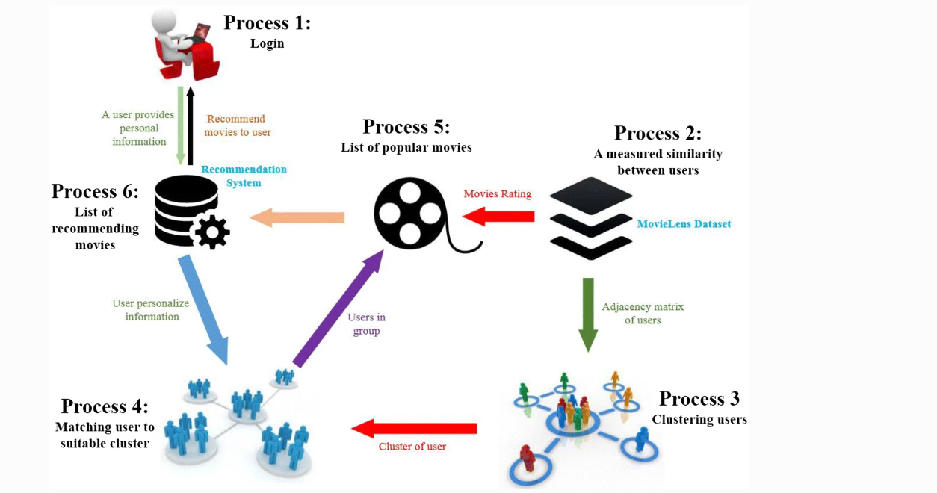

**Figure 4: Movie Recommendation system.**

# Background

## Research works

## 2.2 Review and Analysis of existing work in the problem domain